Digital Health Readiness Assessment Tool and Questionnaire

About this Readiness Assessment Tool and Questionnaire

The digital health readiness assessment tool is a questionnaire and scoring system targeted to managers and healthcare providers.

This readiness assessment from University of Calgary is from the research paper “e-Health Readiness Assessment Tools for Healthcare Institutions in Developing Countries” and has been modified to suit this context. The survey was used successfully in Pakistan (see footnote 113), Botswana and Uganda to determine eHealth adoption readiness. It is intended for managers and healthcare providers to use for planning digital health programs in their own healthcare institutions. Planners can use the results of this tool to evaluate status and progress at various digital maturity stages. The assessment tool is split into four categories: core readiness, technological readiness, learning readiness and societal readiness.

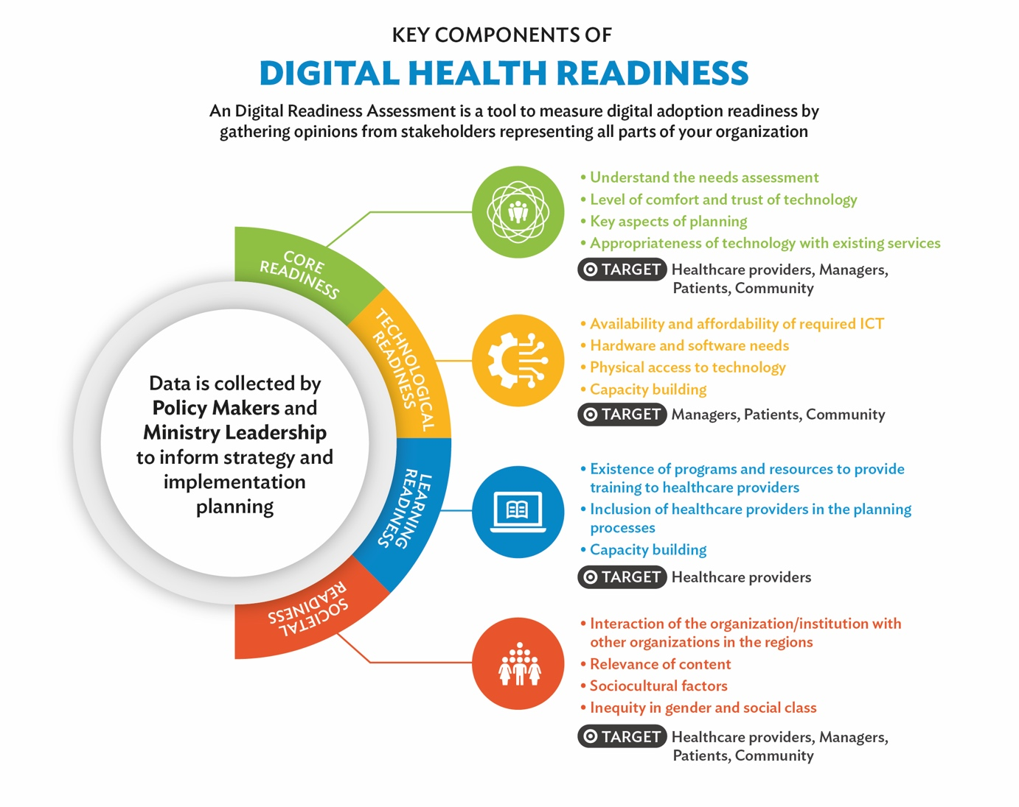
Figure based on: e-Health readiness assessment tools for healthcare institutions in developing countries (see footnote 113).

Scoring
This assessment tool uses a five-point scale. DK means “Don’t know” and receives a score of zero. The higher the score, the closer your organization is to being prepared to move to setting an eHealth strategy and implementation agenda. In a separate spreadsheet, aggregate the scores for each section and document participants’ comments and stories.

How to use the readiness assessment tool
The questionnaire is targeted to managers and healthcare providers. This survey uses semi-structured interviews with consensus developed around the score for each question, depending on the interviewee’s own perspective. Every organization is different and how you collect the data from this questionnaire should be done in a way that optimizes unbiased opinions from a variety of stakeholders.

e-Health readiness questionnaire
This tool has been adapted from “e-Health Readiness Assessment Tools for Healthcare Institutions in Developing Countries”.

Core Readiness
 | Score
Statements | DK | 1 | 2 | 3 | 4 | 5
Identification of needs for future changes, which the proposed eHealth/telehealth project will address
- Organization has properly identified its needs. | ☐ | ☐ | ☐ | ☐ | ☐ | ☐
- Solutions other than eHealth/telehealth have been explored. | ☐ | ☐ | ☐ | ☐ | ☐ | ☐
Dissatisfaction with status quo on the prioritized needs (related to the proposed project)
- There is general dissatisfaction with current handling of issues that could be addressed through eHealth/telehealth. | ☐ | ☐ | ☐ | ☐ | ☐ | ☐
- Solutions other than eHealth/telehealth have been explored. | ☐ | ☐ | ☐ | ☐ | ☐ | ☐
Awareness about eHealth/telehealth in the organization
- Awareness of ICT and internet’s role in healthcare exists among the planners. | ☐ | ☐ | ☐ | ☐ | ☐ | ☐
- Awareness of ICT and internet’s role in addressing the prioritized needs exists among the planners. | ☐ | ☐ | ☐ | ☐ | ☐ | ☐
Level of technology and healthcare literacy
- There is general comfort in using ICT/internet among users of the proposed eHealth/telehealth project. | ☐ | ☐ | ☐ | ☐ | ☐ | ☐
- There is general comfort among staff in using ICT/internet for storing patient information. | ☐ | ☐ | ☐ | ☐ | ☐ | ☐
- There is general comfort among staff in using ICT/internet for the purpose of patient care and education. | ☐ | ☐ | ☐ | ☐ | ☐ | ☐
- There is general comfort among patients in using ICT/internet as part of daily living. | ☐ | ☐ | ☐ | ☐ | ☐ | ☐
- There is general comfort among patients in using ICT/internet for the purpose of patient care and education. | ☐ | ☐ | ☐ | ☐ | ☐ | ☐
Comfort with technology
- There is general comfort in using ICT/internet among users of the proposed eHealth/telehealth project. | ☐ | ☐ | ☐ | ☐ | ☐ | ☐
- There is general comfort among staff in using ICT/internet for storing patient information. | ☐ | ☐ | ☐ | ☐ | ☐ | ☐
- There is general comfort among staff in using ICT/internet for the purpose of patient care and education. | ☐ | ☐ | ☐ | ☐ | ☐ | ☐
Trust on the use of ICT
- All the policymakers and senior administrators trust new technology as a solution to the identified problems | ☐ | ☐ | ☐ | ☐ | ☐ | ☐
- All the staff members trust new technology as a solution to the identified problems | ☐ | ☐ | ☐ | ☐ | ☐ | ☐
- There are plans in place to increase staff’s trust and confidence in the new technology | ☐ | ☐ | ☐ | ☐ | ☐ | ☐
Planning for the new eHealth project
- An individual or a group has taken responsibility for planning | ☐ | ☐ | ☐ | ☐ | ☐ | ☐
- All the user groups among staff and other stakeholders have been involved in planning | ☐ | ☐ | ☐ | ☐ | ☐ | ☐
- There is an appropriate plan for implementation of eHealth/telehealth initiative | ☐ | ☐ | ☐ | ☐ | ☐ | ☐
- The implementation plan includes proper budgeting and identification of resources with a specific budget for eHealth | ☐ | ☐ | ☐ | ☐ | ☐ | ☐
- There is an appropriate plan for evaluation of eHealth/telehealth initiative, including option for external evaluation | ☐ | ☐ | ☐ | ☐ | ☐ | ☐
Overall satisfaction and willingness
- The proposed technology is appropriate according to the conditions within the organization | ☐ | ☐ | ☐ | ☐ | ☐ | ☐
- There is a willingness among staff to implement the technology for its intended purpose | ☐ | ☐ | ☐ | ☐ | ☐ | ☐
Integration of technology
- Integration of technology with the current services has been considered in the planning process | ☐ | ☐ | ☐ | ☐ | ☐ | ☐
- There is a plan in place to integrate eHealth/telehealth with the current services | ☐ | ☐ | ☐ | ☐ | ☐ | ☐

Technological readiness
 | Score
Statements | DK | 1 | 2 | 3 | 4 | 5
Speed and quality of ICT/internet at the institution
- Speed of connections is appropriate for the proposed use | ☐ | ☐ | ☐ | ☐ | ☐ | ☐
- Quality of connections is appropriate for the proposed use | ☐ | ☐ | ☐ | ☐ | ☐ | ☐
Service/support for ICT
- Service/support is available within a reasonable time frame for the proposed use | ☐ | ☐ | ☐ | ☐ | ☐ | ☐
- Local support is proficient to address most of the problems related to the proposed use | ☐ | ☐ | ☐ | ☐ | ☐ | ☐
Hardware and software
- Hardware and software required for the proposed project are readily available | ☐ | ☐ | ☐ | ☐ | ☐ | ☐
- Hardware and software required for the proposed project are readily affordable | ☐ | ☐ | ☐ | ☐ | ☐ | ☐
Availability and affordability of the desired ICT:
- Required ICT (telephone/internet/bandwidth) is easily available for the institution | ☐ | ☐ | ☐ | ☐ | ☐ | ☐
- Required ICT (telephone/internet/bandwidth) is easily available for the institutions involved | ☐ | ☐ | ☐ | ☐ | ☐ | ☐
Institutional access to ICT/Internet training:
- Programs are in place to train the users for proposed project. | ☐ | ☐ | ☐ | ☐ | ☐ | ☐
- Manpower is in place to train the users for proposed project. | ☐ | ☐ | ☐ | ☐ | ☐ | ☐
Speed and quality of ICT/Internet at the institution:
- Speed of connections is appropriate for the proposed use | ☐ | ☐ | ☐ | ☐ | ☐ | ☐
- Quality of connections is appropriate for the proposed use | ☐ | ☐ | ☐ | ☐ | ☐ | ☐
Service/Support for ICT:
- Service/support is available within a reasonable time frame for the proposed use. | ☐ | ☐ | ☐ | ☐ | ☐ | ☐
- Local support is proficient to address most of the problems related to the proposed use. | ☐ | ☐ | ☐ | ☐ | ☐ | ☐

Learning readiness
 | Score
Statements | DK | 1 | 2 | 3 | 4 | 5
ICT/internet training for healthcare providers
- Personnel and programs are in place for training | ☐ | ☐ | ☐ | ☐ | ☐ | ☐
Use of ICT/internet to enhance education of care providers
- Programs exist for continuous education | ☐ | ☐ | ☐ | ☐ | ☐ | ☐
- ICT/internet is readily used in continuous education | ☐ | ☐ | ☐ | ☐ | ☐ | ☐
- Programs are in place to use ICT/internet for continuous education | ☐ | ☐ | ☐ | ☐ | ☐ | ☐
Involvement of healthcare providers in eHealth/telehealth projects
- There is a plan in place to involve healthcare providers in the planning of new eHealth/telehealth interventions | ☐ | ☐ | ☐ | ☐ | ☐ | ☐
- There is a plan in place to involve healthcare providers in the implementation of new eHealth/telehealth interventions | ☐ | ☐ | ☐ | ☐ | ☐ | ☐

Societal readiness
 |  | Score
Statements |  | DK | 1 | 2 | 3 | 4 | 5
Communication with other organizations
- Staff regularly uses ICT/internet to communicate with staff at the other health institutions of the region |  | ☐ | ☒ | ☐ | ☐ | ☐ | ☐
- Staff regularly uses ICT/internet to communicate with local community and clients |  | ☐ | ☐ | ☐ | ☐ | ☐ | ☐
- Other institutions involved in the eHealth/telehealth project have also planned to go through e-readiness assessment |  | ☐ | ☐ | ☐ | ☐ | ☐ | ☐
[For e-learning projects] Sharing of locally relevant content between healthcare institutions
- Material on locally relevant health issues is shared between this institution and other institutions |  | ☐ | ☐ | ☐ | ☐ | ☐ | ☐
- The relevant material is available in language(s) that is easily understood by all the concerned staff and other users of information |  | ☐ | ☐ | ☐ | ☐ | ☐ | ☐
[For service-related projects] Providing care to patients and communities in collaboration with other healthcare institutions
- A referral system is available between this institution and other healthcare institutions to provide patient care in certain specialties |  | ☐ | ☐ | ☐ | ☐ | ☐ | ☐
- ICT is currently used for referrals between this institution and other healthcare institutions |  | ☐ | ☐ | ☐ | ☐ | ☐ | ☐
Considering sociocultural factors among staff
- Both the genders have equal and unrestricted access to the technology |  | ☐ | ☐ | ☐ | ☐ | ☐ | ☐
- Staff from all levels get direct benefit from the use of technology |  | ☐ | ☐ | ☐ | ☐ | ☐ | ☐
Considering sociocultural factors among clients and communities
- Use of ICT will benefit men and women equally in the society |  | ☐ | ☐ | ☐ | ☐ | ☐ | ☐
- People from all socioeconomic strata get direct benefit from the use of technology |  | ☐ | ☐ | ☐ | ☐ | ☐ | ☐
ICT related regulations
- Government policies are in place to promote and manage use of eHealth/telehealth in healthcare institutions |  | ☐ | ☐ | ☐ | ☐ | ☐ | ☐
- Institutional policies are in place to promote and manage use of eHealth/telehealth in your institution |  | ☐ | ☐ | ☐ | ☐ | ☐ | ☐
Policies regarding licensing and liability:
- Government policies are in place to allow care provision in other jurisdictions through telehealth |  | ☐ | ☐ | ☐ | ☐ | ☐ | ☐
- Institutional policies are in place to allow care provision in other jurisdictions through telehealth |  | ☐ | ☐ | ☐ | ☐ | ☐ | ☐
- Government policies are in place to deal with liability issues |  | ☐ | ☐ | ☐ | ☐ | ☐ | ☐
- Institutional policies are in place to deal with liability issues |  | ☐ | ☐ | ☐ | ☐ | ☐ | ☐
 | Policies regarding reimbursement
- Government policies are in place to ensure proper reimbursement to the healthcare providers in your institution |  | ☐ | ☐ | ☐ | ☐ | ☐ | ☐
- Institutional policies are in place to ensure proper reimbursement to the healthcare providers in your institution |  | ☐ | ☐ | ☐ | ☐ | ☐ | ☐
 | Policies regarding system interoperability
- Government policies are in place to ensure/specify interoperability standards and system requirements |  | ☐ | ☐ | ☐ | ☐ | ☐ | ☐
Awareness and support of ICT among politicians:
- Politicians are generally aware of the benefits of ICT use in healthcare |  | ☐ | ☐ | ☐ | ☐ | ☐ | ☐
- Politicians generally support the use of ICT use in healthcare |  | ☐ | ☐ | ☐ | ☐ | ☐ | ☐
Awareness and support of ICT among policymakers at the institutional level
- Policy makers are aware of the benefits of ICT in healthcare institutions |  | ☐ | ☐ | ☐ | ☐ | ☐ | ☐
- Policy makers support the use of ICT in healthcare institutions |  | ☐ | ☐ | ☐ | ☐ | ☐ | ☐

Khoja, S., Scott, R.E., Casebeer, A.L., Mohsin, M., Ishaq, A.F.M., Gilani, S. 2007. e-Health readiness assessment tools for healthcare institutions in developing countries, Telemedicine Journal and e-Health, September 2007.
Mauco, L., Scott, R., and Mars, M., 2020. Validation of an e-health readiness assessment framework for developing countries. BMC Health Services Research—under review, March.
Kiberu, V., Mars, M., Scott, R., 2019. Development of an evidence-based e-health readiness assessment framework for Uganda. Health Information Management Journal. April.
Khoja, S., Scott, R.E., Casebeer, A.L., Mohsin, M., Ishaq, A.F.M., Gilani, S. 2007. e-Health readiness assessment tools for healthcare institutions in developing countries, Telemedicine Journal and e-Health, September 2007.

